horizontal line

Setting-up for CS425-SWE

Monday, 09.30.2019

**─**

## 0. Java SE Development Kits (JDKs).

## [Note: For a detailed step-by-step guide with screenshots for setting-up JDKs for a Windows PC, you may follow the "Detailed DevTools Setup Steps for Microsoft Windows PCs", provided further down, below]

1. **JDK8 (Required)**
   1. Go to <http://www.oracle.com/technetwork/java/javase/downloads/index.html>, and download the installer for Oracle JDK for Java SE 8, appropriate for your operating system. The current JDK8 update is Java SE 8u221.
   2. **Windows**: To install it on a Windows PC, simply execute the installer and complete the steps of the installation wizard, making a note of the folder where you have selected to install the JDK.
   3. Create a new environment variable named, **JAVA_HOME**, setting it to the JDK's installation folder (which you made a note of, in step 1.2 above).
   4. Add the following, **%JAVA_HOME%\bin**, to the top (head) of the PATH environment variable's setting.
   5. Open a Windows Command window (i.e. run "cmd" to open a command prompt).
   6. Verify your JDK installation: To do this, at the command prompt, type and execute the following command, "javac -version". This should successfully print, **"javac 1.8.0_221"**, which is the version information for the Java language compiler contained in the Java SE 8 JDK.
2. JDK11 (optional)
3. JDK12 (optional)
4. JDK13 (optional)

## 1. IDE options

1. Eclipse IDE for Enterprise Java Developers
   1. Go to <https://www.eclipse.org/downloads/packages/>, and download the current version of "Eclipse IDE for Java EE Developers". Select the one appropriate for your computer's operating system. **Note**: The latest version is, [**Eclipse 2019-09 R**](https://www.eclipse.org/downloads/download.php?file=/technology/epp/downloads/release/2019-03/R/eclipse-jee-2019-03-R-win32-x86_64.zip).
   2. After downloading, to set it up on Windows, simply unzip the downloaded zip archive file into a folder of your choice.
   3. To launch the IDE, simply run/execute the file named, eclipse.exe.
   4. [You may also use the [Eclipse Installer](https://www.eclipse.org/downloads/), if you prefer].
2. [IntelliJ IDEA 2019.2.3](https://www.jetbrains.com/idea/download/)
3. Netbeans 8.2
4. [Spring Tools 4 or Spring Tools Suite (STS) 4](http://spring.io/tools)
5. JBoss Dev Studio
6. Or any other IDE/Code Editor tool, you prefer.

## 

## 2. Web Browser options

1. Google Chrome
2. Mozilla Firefox
3. Microsoft Edge
4. Safari
5. Opera etc.

## 3. Basic Tools

1. 7Zip or some other file compression/decompression tool
2. Adobe Reader

## 4. Build/Dependency Mgmt tools

1. Apache Maven

1.1 Obtain the Apache Maven package from <https://maven.apache.org/>

1.2 Download the zip archive (for Windows - <http://mirrors.advancedhosters.com/apache/maven/maven-3/3.6.1/binaries/apache-maven-3.6.1-bin.zip>

1.3 To install, simply unzip the zip archive (i.e. [apache-maven-3.6.1-bin.zip](http://mirrors.advancedhosters.com/apache/maven/maven-3/3.6.1/binaries/apache-maven-3.6.1-bin.zip)) on to a folder on your computer.

1.4 To start running/using maven, you need to set the following 2 environment variables:

1.4.1 set variable named, MAVEN_HOME, with the value to be the path of your maven folder

1.4.2 set variable named, M2_HOME, with the value to be the path of your maven folder

1.4.3 For convenience, add the path to the maven 'bin' folder to your Path environment variable

1.5 To test/verify that maven is setup and configured correctly, simply open a commandline window and execute the command: c:\> mvn --version

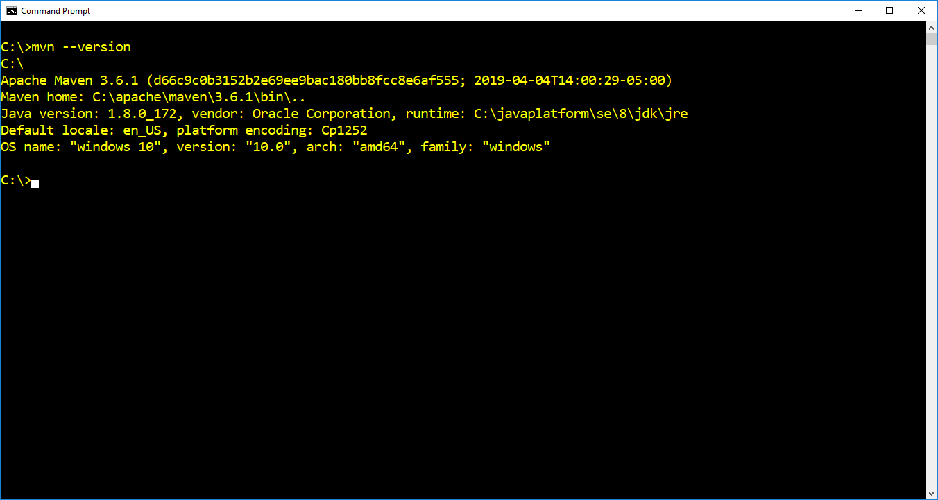

2. Gradle

3. MSBuild

4. SBT

## 5. Code Editor options

1. Visual Studio Code
2. Notepad++
3. Atom
4. SublimeText
5. EditPlus or any other

------------------------------------------------------------------------------------------------------------------------------------

## 6. Recommended Textbook(s):

* 1. Agile Software Development: Principles, Patterns and Practices by Robert C. Martin (Author), Prentice Hall, 2002
  2. Patterns of Enterprise Application Architecture by [**M**](https://play.google.com/store/books/author?id=Michael+T.+Goodrich)artin Fowler, Addison-Wesley, 2002
  3. UML Distilled by Martin Fowler

----------------------------------------------------------------------------------------------------------------------------------

**Detailed DevTools Setup Steps for Microsoft Windows PCs:**

1. Download and install the Java Platform SE JDKs:
   1. JDK 8:
      1. <http://www.oracle.com/technetwork/java/javase/downloads/jdk8-downloads-2133151.html>
      2. Documentation bundle: <http://www.oracle.com/technetwork/java/javase/documentation/jdk8-doc-downloads-2133158.html>
      3. To install JDK 8 on Windows, do the following steps:
         1. Create a new folder on your primary disk drive, C, named "javaplatform".
         2. Inside the 'javaplatform' folder, create a sub-folder named, 'se' (for installing all the Java SE JDKs)
         3. Inside 'se' create a sub-folder named, '8'. And inside '8', create a sub-folder named, 'jdk' (This will be the JAVA_HOME folder!).
         4. Execute the JDK Windows installer file (jdk-8u172-windows-x64.exe), downloaded and go through the installation wizard steps, **making sure to select for it to install the JDK into the folder at c:\javaplatform\se\8\jdk**. i.e. At the install wizard screen shown below, be sure to click on 'Change' button and then browse and select the new destination folder to be - c:\javaplatform\se\8\jdk. 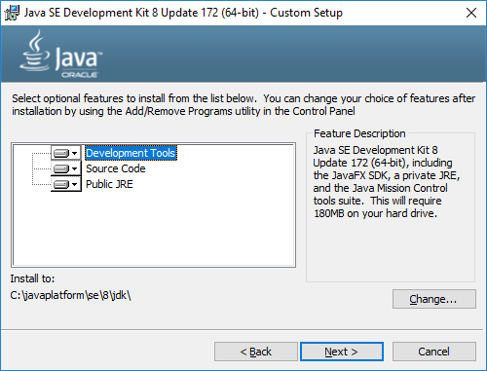
         5. Note: It is okay to let the JRE component, install to the c:\Program Files... folder.
         6. When the installation wizard finishes, click Close.
         7. Tap the "Windows" key, type the letters, 'env' and select the "Edit System Environment Variables" menu option that appears on the Windows Start menu.
         8. Click 'Environment Variables' button on the 'System Properties' dialog.
         9. On the 'Environment Variables' window, add the following 2 settings: a) Click on 'New' button and add a new environment variable named, JAVA_HOME, setting its value to the jdk8 home folder, 'c:\javaplatform\se\8\jdk. b) Click on the 'Path' environment variable entry and click Edit and add a new path as, %JAVA_HOME%\bin. And be sure to move it up the list **to the very top, above every other JDK or JAVA HOME folder path, including any %JAVA_HOME%\bin, previously added**. 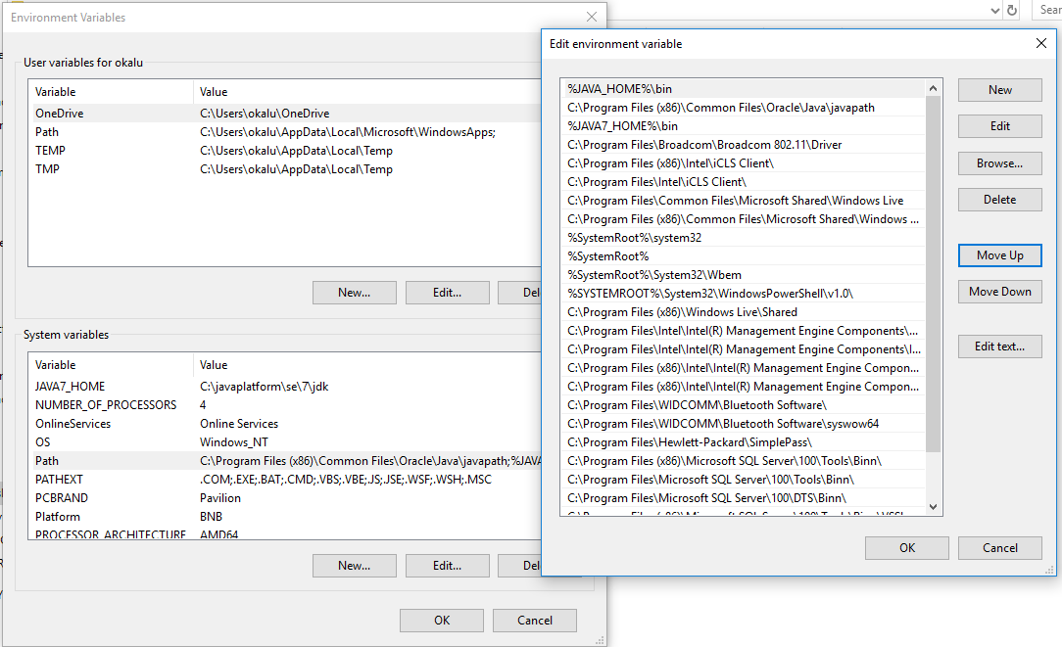
         10. Click 'OK', 'OK' ... to save the settings and close the Environment Variables windows.
         11. Next, open Windows Explorer and navigate to the 'bin' folder inside the JDK 8 folder, c:\javaplatform\se\8\jdk\bin. Select the file named, javac.exe, make a copy of it by Pressing Ctrl C to copy and Ctrl V to paste. Then, select and rename the copy of the file, to a new name, javac8.exe.
         12. Do the same for the following other file(s): java.exe to java8.exe.
         13. To check/verify the new JDK 8 installation, simply open a new Windows Command Prompt window, and enter the command: c:\>***javac8 -version.*** This should successfully display the version information of the Java JDK 8 compiler, as shown below. And running the command, c:\>javac -version should also display the version information. Likewise, the commands, c:\>java8 -version and c:\>java -version should both also display the version information of the JVM. All as shown in the screenshot below: 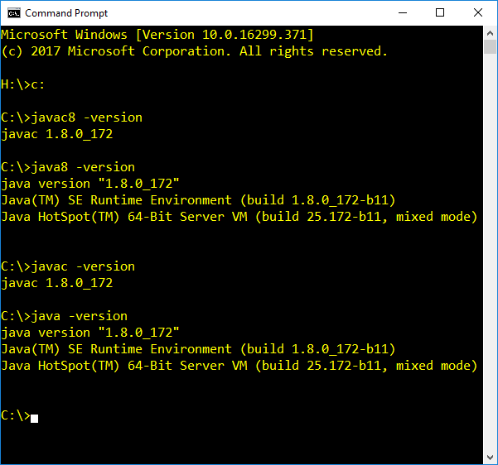
         14. Note: This configuration has set JDK 8 as the primary JDK and JAVA_HOME. The idea behind this setup is to enable having multiple versions of the Java JDK installed side-by-side and be able to switch primary JDK and JAVA_HOME from one to the other, by simply changing the JAVA_HOME environment variable.
         15. With this, JDK 8 setup is done!
   2. JDK 11:
      1. JDK: <http://www.oracle.com/technetwork/java/javase/downloads/index.html>
      2. Java SE 11 API Documentation bundle: [http://www.oracle.com/technetwork/java/javase/documentation/jdk11-doc-downloads-4417029.html](http://www.oracle.com/technetwork/java/javase/documentation/jdk10-doc-downloads-4417029.html)
      3. To install JDK 11 on Windows, do the following steps:
         1. [Follow similar steps as in JDK 8 above]
   3. To install and setup the JDK for other operating systems:
      1. Linux: <https://docs.oracle.com/javase/8/docs/technotes/guides/install/linux_jdk.html>
      2. Mac OS: <https://docs.oracle.com/javase/8/docs/technotes/guides/install/mac_jdk.html>
2. Download and install Java IDE(s):
   1. Eclipse:
      1. Download the latest release of Eclipse IDE for Enterprise Java development from <https://www.eclipse.org/downloads/packages/>.
      2. To install, grab the zip package and simply unzip to a folder. Create a shortcut and then Pin to Taskbar. Note: You may use the Eclipse IDE installer, if you prefer that.
   2. JetBrains IntelliJ IDEA:
      1. Download Ultimate or Community edition from JetBrains website. Note: With your student/academic email address, Jetbrains offers you the Ultimate edition of their products for free, with a one yearly renewable educational license.
   3. Spring Tool Suite:
      1. This can be obtained from <http://spring.io/tools>
      2. You may also grab/install, [Spring Boot CLI](https://docs.spring.io/spring-boot/docs/current/reference/html/cli-installation.html) from [spring.io](http://spring.io/), as well. And follow its [documentation guide](https://docs.spring.io/spring-boot/docs/current/reference/html/getting-started-installing-spring-boot.html) to install and work with it (Will demonstrate this in class, around Week 3 Friday, as part of Spring Security topic).
3. Code Editors:
   1. [Visual Studio Code (VSCode)](https://code.visualstudio.com/) (including extension packs for Java development, Spring development etc.)
   2. Notepad++: Download the zip package and simply unzip to a folder. Or get and use the installer, if you prefer.
4. HTTPServer (i.e. web server)
   1. nginx - a popular, free, open-source web server product
      1. To obtain nginx, go to http://www.nginx.com
      2. Download a mainline or stable version for your OS from <https://nginx.org/en/download.html>
      3. To install, for Windows OS, simply unzip the downloaded zip package to a folder location of your choice on your computer. e.g. c:\nginx\1.17.0>
      4. To check the setup config and test the product's installation, simply launch open a command window and execute - c:\nginx\1.17.0>**nginx -t**
      5. To start the web server, execute - c:\nginx\1.17.0>**start nginx** (Make sure there is no other service running/listening on the default port, 80. To check that the nginx web server is up and running, execute - c:\nginx\1.17.0>**tasklist /fi "imagename eq nginx.exe"**. This displays the list of running nginx process(es). And to access the default website, open a browser and navigate to http://localhost:80/
      6. To stop the nginx server, execute - c:\nginx\1.17.0>**nginx -s quit**
      7. Documentation for Windows - <http://nginx.org/en/docs/windows.html>
   2. apache httpd - another free, open-source web server product; from apache software foundation
   3. Microsoft Windows Internet Information Server (IIS) - comes with Windows OS.
5. App server software (or Java Web Servlet container):
   1. Apache tomcat
      1. Obtain apache tomcat from [http://tomcat.apache.org](http://tomcat.apache.org/) by downloading the binary zip archive for the latest version
      2. To install it, simply unzip the zip archive.
      3. tbc...
   2. Jetty:
   3. Undertow:
   4. Resin:
   5. WebLogic
   6. JBoss EAP or AS:
   7. node.js etc.
6. Other tools:
   1. MySQL Community (Database) Server and tools - <https://dev.mysql.com/downloads/mysql/>. (For installation instructions, go here - <https://dev.mysql.com/doc/refman/8.0/en/installing.html>)
      1. How to set it up:
      2. For Windows: ...
         1. ...
      3. For Mac OS:
         1. See <https://www.youtube.com/watch?v=UcpHkYfWarM>
      4. ...
   2. [Apache Maven](https://maven.apache.org/download.cgi) (or Gradle)
      1. For tutorial guide on its installation and use, see Sakai++ folder.
   3. [Git](https://git-scm.com/downloads) 
      1. Git GUI client tool options:
         1. SourceTree by Atlassian - <https://www.sourcetreeapp.com/>
         2. Github Desktop
         3. GitKraken
   4. UML tool such as StarUML or Visual Paradigm or some other online UML tool (e.g. <https://www.draw.io/>), if you prefer.

---------------------------------------------------------

Supplementary material - Papers, Articles, Reference docs etc.

1. MicroServices - 1.1<https://www.redhat.com/en/topics/microservices?sc_cid=701f2000001OJW8AAO>

1.2 Martin Fowler's Microservices tech talk video on youtube

2. Spring Boot application properties - <https://docs.spring.io/spring-boot/docs/current/reference/html/common-application-properties.html>

**Spring Platform and supplementary topics:**

1. Spring WebMVC (Servlet programming-model (and not the Reactive model (yet)))

1.1 Thymeleaf (UI/View Engine) including the thymeleaf-layout library for applying Layouts and structure to the UI

1.2 Packaging and deploying to external tomcat

2. Spring Data JPA

3. Spring Boot and Spring CLI

4. Spring REST (for restful services)

5. Spring Security

6. Spring DevTools

7. Lombok

8. Profiles

9. Logging, Testing

**DevOps topics:**

1. CI/CD - Jenkins, Travis, AWS devops etc.

2. Containers and orchestration - Docker, Kubernetes

3. Test Automation - Selenium web application UI testing framework, HP LoadRunner, Katalon, Apache JMeter etc

4. Team/Project Mngmt/ALM tools - Atlassian Jira, Confluence, or Microsoft Team, Slack etc.

**CS425 - SWE - Course Prerequisite knowledge and associated MSCS courses:**

1. Web Application development Basics (HTTP, HTML, CSS, Javascript etc.) - CS472-WAP.

2. Database design and development basics - CS422-DBMS.

3. Design Patterns - CS572-ASD